
College of Computing and Mathematics

Term 241
ICS 321: Database Systems (241) Course Project
Database Systems Project (PHASE 2)
2024 / 12 / 11

Sec:1
Group:21

202178710 Basel Alzahrani
202016260 Ayman Al Johani
202170650 Ziyad Alrushud

Constraints and Business Rules
- Business Rules
- Only one track exists between any two stations.
- All stations are in a connected graph.
- Every train has a unique ID and an Arabic and an English name.
- Each train reaches its destination on the same day
- Every train with the same train ID runs once every day
- Each route has a sequence number for the stations.
- Each passenger has luggage details.
- Passengers are required to upload their identification document during the reservation process.
- Each dependent/family member receives a 25% discount on the total ticket amount.
- Three loyalty classes based on miles travelled: Green (5% discount after 10K miles travelled), Silver (10% discount after 50K miles travelled) and Gold (25% discount after 100K miles travelled).
- 15% VAT applies to ticket price.
- Reservation is not confirmed until a payment is made before a certain date. Otherwise, the reservation is cancelled.
- Cancellation charges of 15% are applied for all reservations that are cancelled after the payment is made.

- Technical Constraints
- Each entity should have a unique identifier as a primary key.
- Primary Key cannot be repeated.
- No primary key value can be NULL.
- Foreign keys cannot reference a primary key that doesn’t exist.
- trigger to limit 5 active reservations per passenger.
- Coach type can only be economy or business.
- Check loyalty status based on miles(Green, Silver and Gold).

EER
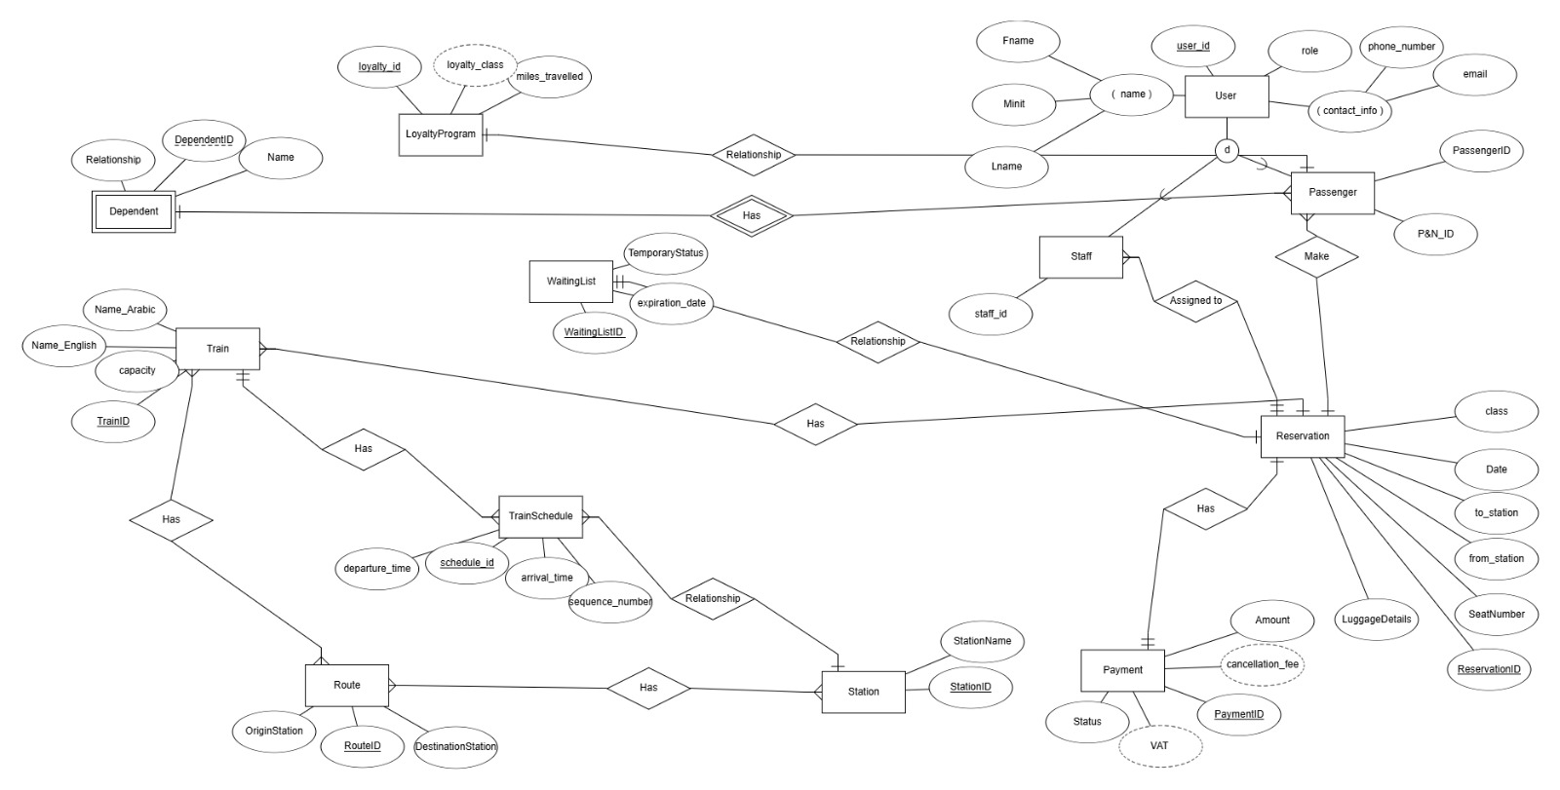

Relational Schema
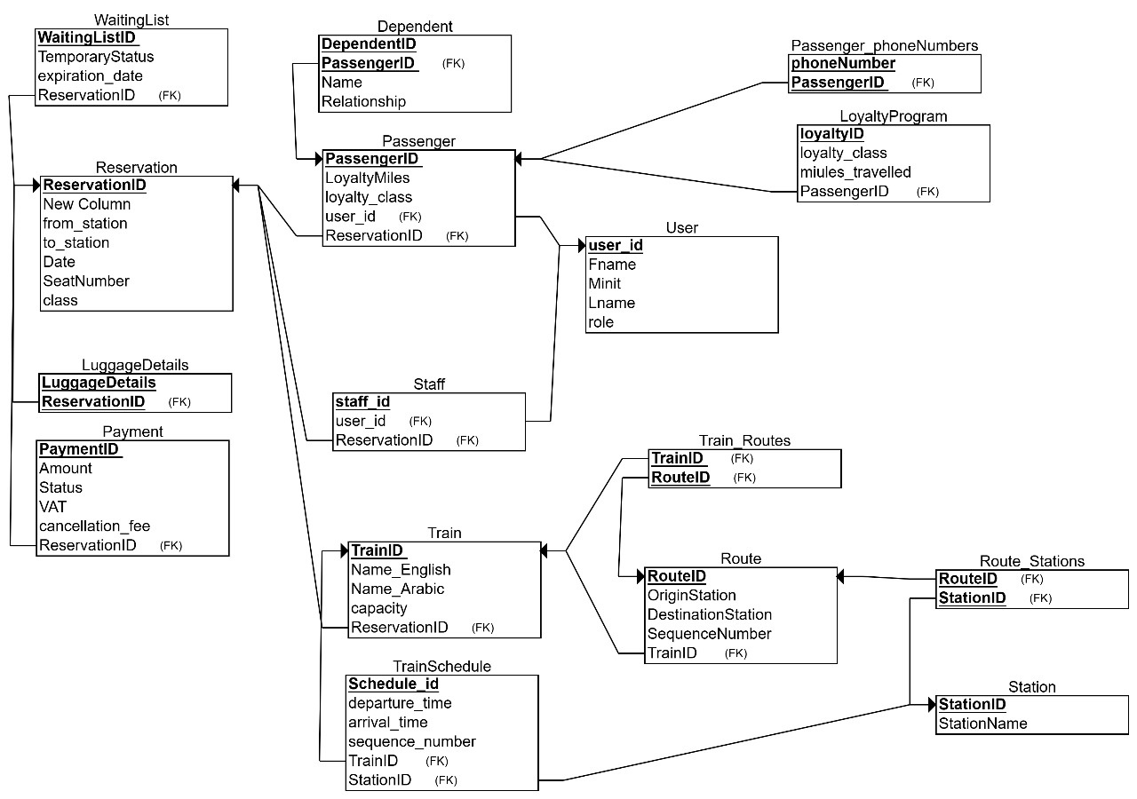

Tools and Resources
- ERDPlus
- PHP for backend
- HTML, CSS and JavaScript for frontend
- MySQL as a database
- Xampp and phpMyAdmin to run and administer the server

The hardest Problems we faced and resolved are:
Problem: how to connect HTML to database
Solution: using php that can communicate with the database and HTML
Problem: holding data across sites to know which user is currently on
Solution: using php sessions
Problem: sending queries to the database and getting results.
Solution: using PDO object
Problem: sending data from html to php.
Solution: using <form>

Extra functionalities:
Average load factor (percentage of seats occupied divided by total seats) for each train on a given date (for admins).
List of dependents travelling on a given date in all trains (for admins).

Contribution
 | php | HTML,CSS,JavaScript | SQL
Ayman Al Johani | 0% | 70% | 20%
Basel Alzahrani | 100% | 10% | 10%
Ziyad Alrushud | 0% | 20% | 70%

Suggestions to improve ICS 321 future projects:
We highly encourage the course to have lab sections so students be more familiar with other technologies that can use the database, so they don’t have to learn several new technologies to do the project.

